MySQL diagram for Auction application
The database “auction” consists of 2 tables
- Users table
Any new users which login are stored here and the values for coins and inventory are initialized as per the requirement.
- Current_auction table
Current auction table stores the details of the ongoing auction which is placed when a user clicks on the start auction button from the inventory list. These details are broadcasted using sockets to all users.
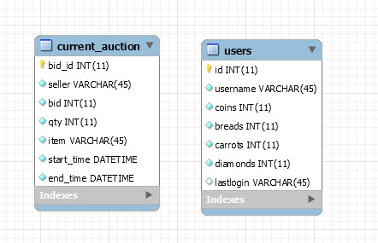

List of technologies
- Node.js
- Express
- AngularJS
- Angular material design library
- Mocha
- Chai
- Mysql for database
- Socet.io for web sockets

Design Patterns
- CommonJS modules pattern
JavaScript runs everything in the global scope and we need to use a dependency management system that will take care of things like overwriting variables. Node uses CommonJs Modules for handling dependency.
CommonJS dependency management revolves around two methods exports & require.

- Callback pattern
A call back basically is a function that will get invoked after the initiated task is completed. In Node, since everything is async, the callback gets fired on completion of an I/O operation.

- Event Emitter Pattern
- Dependency Injection In AngularJs
- Prototype Design Pattern
- Observer Design Pattern
In AngularJS, if the $scope object updates, an event can be triggered to notify another component. If an object is modified it broadcasts to dependent objects that a change has occurred.
- Singleton
MySQL Db
Application Flowchart
Node.js server running express on top
New user logs in by using a unique username
Login.html

Page: login.html

New user is given 1000 coins, and at the inventory: 30 breads, 18 carrots and 1 diamond.

User starts an auction of any one of the inventory items
Ongoing auction details are sent using websockets

